Python code to display Audio waveform
Instructions :-
- Open colab.research.google.com
- Create a new notebook and write the code below and save the notebook
- Place the test.wav file in the drive folder where python code is saved

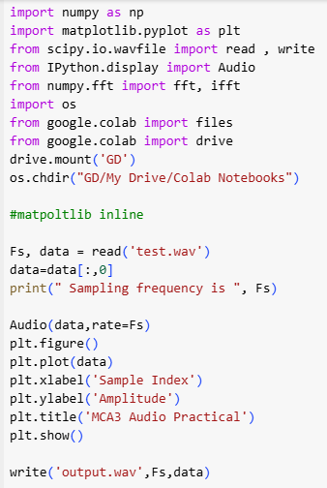
Python code step by step:
Importing Libraries:
- import numpy as np
- import matplotlib.pyplot as plt
- from scipy.io.wavfile import read, write
- from IPython.display import Audio
- from numpy.fft import fft, ifft
- import os
- from google.colab import files
- from google.colab import drive
  - numpy is imported as np for numerical operations.
  - matplotlib.pyplot is imported as plt for plotting graphs.
  - read and write functions from scipy.io.wavfile are used to read and write WAV files.
  - Audio from IPython.display is used to play audio directly in Jupyter notebooks.
  - fft and ifft from numpy.fft are used for Fast Fourier Transform and its inverse.
  - os is used for interacting with the operating system.
  - files and drive from google.colab are used for file operations and mounting Google Drive in Colab.
Mounting Google Drive:
- drive.mount('GD')
- os.chdir("GD/My Drive/Colab Notebooks")
  - drive.mount('GD') mounts Google Drive to the Colab environment.
  - os.chdir("GD/My Drive/Colab Notebooks") changes the current working directory to a specific folder in Google Drive.
Reading the Audio File:
- Fs, data = read('test.wav')
- data = data[:, 0]
- print("Sampling frequency is ", Fs)
  - Fs, data = read('test.wav') reads the WAV file test.wav. Fs is the sampling frequency, and data is the audio data.
  - data = data[:, 0] selects the first channel if the audio is stereo.
  - print("Sampling frequency is ", Fs) prints the sampling frequency.
Playing the Audio:
- Audio(data, rate=Fs)
  - Audio(data, rate=Fs) plays the audio data at the specified sampling rate.
Plotting the Audio Data:
- plt.figure()
- plt.plot(data)
- plt.xlabel('Sample Index')
- plt.ylabel('Amplitude')
- plt.title('MCA3 Audio Practical')
- plt.show()
  - plt.figure() creates a new figure.
  - plt.plot(data) plots the audio data.
  - plt.xlabel('Sample Index') labels the x-axis.
  - plt.ylabel('Amplitude') labels the y-axis.
  - plt.title('MCA3 Audio Practical') sets the title of the plot.
  - plt.show() displays the plot.
Writing the Audio File:
- write('output.wav', Fs, data)
  - write('output.wav', Fs, data) writes the audio data to a new WAV file output.wav with the same sampling frequency.

